
Love
From the smallest of seeds filled with faith and love, our St John’s family will flourish and grow.

Faith

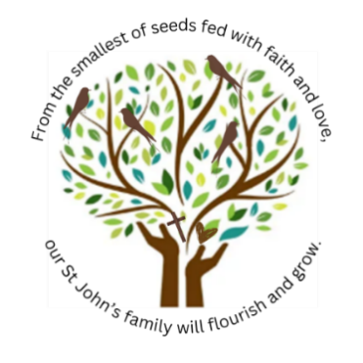


EOT4 NEWSLETTER
Message from the Executive Headteacher
Term 4 seemed to come and go in a flash! It was a busy time for all classes in the school. Butterflies were showing their caring nature planting and caring for flowers in the Spring. Squirrels were telling me all about famous landmarks in London and Owls were able to describe the work of Isambard Kingdom Brunel. The children went out on trips, they had visitors in, they raised money for Comic Relief and the school council bought lots of new toys to play with at breaktimes. Thank you for all of your hard work everybody.
Term 5 is a particularly important one for us in primary schools. It is the time when teachers are preparing their classes for national testing weeks. A time to make sure that the children really are trying their best in their school books and a time to know that children are practising all of their reading and writing skills at home.
Later on in this newsletter you will find some top tips that will help parents to ensure their child achieves their best and really does show the world that they are able to flourish and grow.
I would personally like to welcome Beki Edwards your new Headteacher. She is moving from another local school to work with you full time and she is very excited to meet each and every one of you. When you see her on the gates at the start/end of day do stop by and have a chat. She really is the most perfect fit for the school and I am excited to see all of the new adventures you will share together.
In the meantime, I ask you to pin the dates in this newsletter to your diary and sit back and wait for the summer to come…hopefully we won’t have too wait too long!


Introduction to Mrs Edwards – your new Headteacher
I am so excited to meet you all after Easter and begin this new journey together as your Headteacher. I am really looking forward to working with you, getting to know our school community, and making many wonderful memories along the way.
I have been teaching for almost 20 years across a range of local schools, and I feel incredibly proud and excited to now be joining such a warm and welcoming infant school. It is already clear that this is a very special place, and I cannot wait to see all that we can achieve together.
I am passionate about creating a happy, nurturing environment where every child feels safe, valued, and inspired to learn. I believe these early years are vital in developing children’s confidence, curiosity, and love of learning. My aim is to provide a rich and engaging curriculum that supports both academic success and personal development.
Working in partnership with families is incredibly important to me. Together, we can ensure our children have the very best start to their education and thrive in all they do.
My door will always be open, and I am keen to hear your ideas, thoughts, and feedback. By working together, we can continue to build a positive and inspiring school for all.
I look forward to meeting you very soon!

ATTENDANCE MATTERS
Evidence shows that the more schooling your child gets, the better their school results will be, The better your child’s school results, the more financially stable their life chances will be. KEEP BRINGING YOUR CHILD TO SCHOOL

SCHOOL UNIFORM
If you are new to the school or you just need some more uniform come in and speak to us in the school office. We have sets of uniform to give away for free. Come and help yourself.
Likewise, if you have uniform at home that your child no longer needs but somebody else could make use of, please bring it into the office and add it to our free uniform stocks next time you are dropping off or picking up your child.
We thank you for thinking of and sharing with others.

MAKE SURE YOUR CHILD HAS FOOD
Every parent MUST book their child’s school dinner from the website. The catering company only purchases food supplies to cook for the number of orders received online. If you do not book online – children suffer. Let’s make sure that feeding our children is our number one priority. If you need help learning how to book your child’s food online please come into the school office and speak with Mrs Sommerille.


WHAT PARENTS CAN DO TO HELP THEIR CHILD PASS THEIR PHONICS READING TEST
As we approach June, it’s important to prepare our Year 1 children (and those Year 2 pupils who didn’t meet the standard last year) for the phonics screening check. This short assessment involves reading 40 words—20 real and 20 “alien” (pseudo) words—aloud to their teacher, confirming their phonic decoding skills.
To support your child, please visit the virtual classroom on the school website daily and practice the sounds. Encourage blending by having them say each sound in a word from left to right, like /c/-/a/-/t/ for “cat”. Practising pseudo-words will help ensure they are decoding rather than guessing. While reading together, ask them to find digraphs (special friends) such as ‘sh’, ‘ch’, ‘ee’, or ‘igh’. Lastly, encourage reading a variety of materials, including subtitles on TV. Remember, practice little and often! Helping your child learn to read will improve their future.
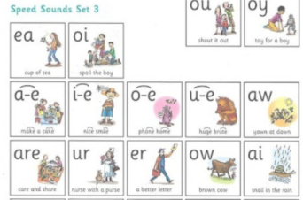

Term 5 Diary Dates

Mon 20th April – all children come back to school

Tues 21st April – Squirrels class trip to the dockyard

Thursday 30th April – Values day in school

Wednesday 13th May – Owls class assembly to parents

Monday 18th May – Owls enterprise event

Tues 19th May -Butterflies enterprise event

Wed 20st May – Squirrels enterprise event

Thurs 22nd May- Road safety visitor day and last day of term



