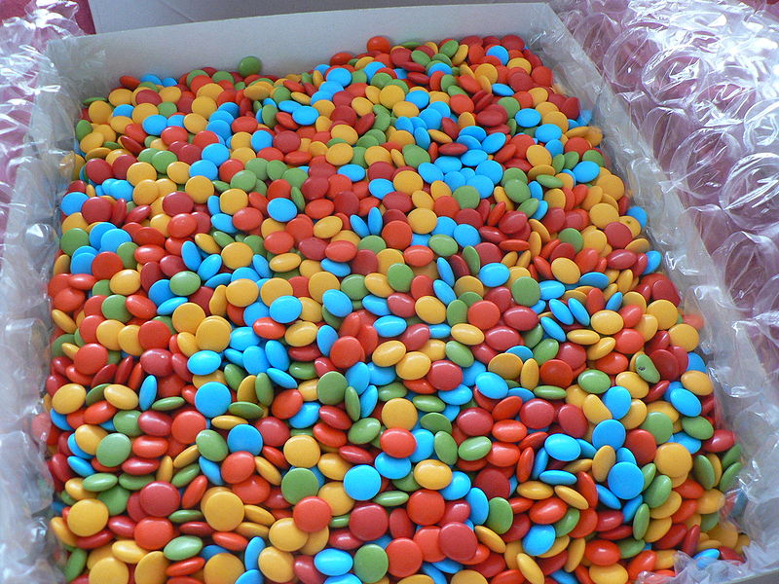
Homework pieces/ evidence should be handed into school on the first day back in the new term (Tues 6th Jan 25). Please make sure you have your name on them. Merry Christmas!
How it Works
You simply need to pick your homework, aiming to spend at least 12p in total.
Year 2 Pick ‘n’ Mix Christmas Holiday Homework

3p  Make lunch with an adult and record how you made it - like your own TV or radio cookery show.  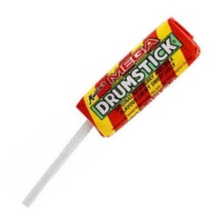 |  | 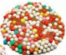  Practise saying your 2, 5 and 10 times tables. Get an adult to write questions down so you can answer them.  1p |   Write down 20 words that end using the suffix –ed then put 10 of them into silly sentences.  1p
Listen to some gentle music and use this time to reflect on what makes you happy.  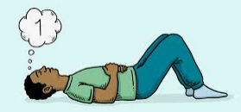  2p | 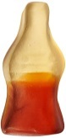  Learn to tie your shoe laces and record a set of instructions to teach somebody else.  4p |   Go to a local park and imagine you are in the Olympic games. What different races/sports could you have a go at?  2p | 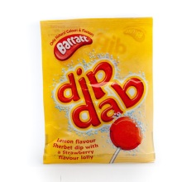  Imagine you are one of Father Christmas’s elves at the North Pole. Write a diary entry about your experiences over Christmas.  3p
  5p  Culture Vulture  Research a famous King or Queen and write 5 facts about them. |   1p |   Read a book and then create a new book cover for it based on events that happen in the book.  2p | 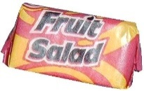  Culture Vulture  This term our topic was 'Movers and Shakers. Who was your favourite significant person. Write 5 facts about them and say why they are your favourite.  2p
  Spend some time on your well- being, maybe complete some yoga https://www.youtube.com/user/C osmicKidsYoga/videos or a just dance video from YouTube.
  REMEMBER: Stay safe online

