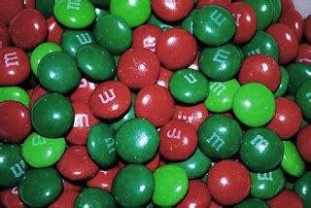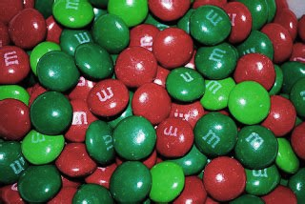
Year 1 Pick ‘n’ Mix Christmas Holiday Homework
How it Works
You simply need to pick your homework, aiming to spend at least 10p in total.
  Culture Vulture  Research a famous person who comes / came from Medway. Write down one thing you learnt about them.  3p | 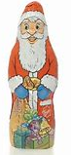  Go for a walk with your family. Can you take pictures of the different things you see?  2p | 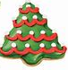  Write a thank you note for your favourite present, why was it your favourite?  4p |   3p  Count the number of houses you see with Christmas lights and add it to the number of Christmas tress you see. How many altogether?
Culture Vulture  Look at paintings by the artist Kandinsky. Can you use colours to recreate Kandinsky’s art work.  2p  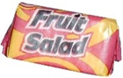 |   3p  Read your favourite book, can you create a new front cover, based on what happens in the book? |   2p  Practise throwing a ball, how many times can you throw and catch it without dropping it? Take some pictures of you practising. | 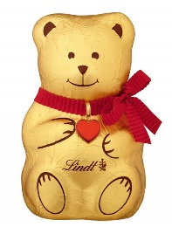  3p  Write your own thank you prayer and decorate it.
  Spend some time on your well- being, maybe complete some yoga https://www.youtube.com/user/C osmicKidsYoga/videos or a just dance video from YouTube.  REMEMBER: Stay safe online  4p | 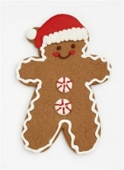  1p  Leave a carrot out for Rudolph and the other reindeer. Can you remember all their names? Take a picture of their tasty snack? | 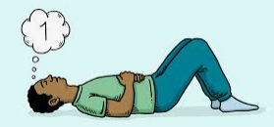  2p  Listen to some gentle music and use this time to reflect on what makes you happy. | 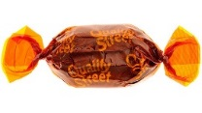  How many number sentences can you make using just the numbers: 8, 7, and 15? Remember you can use + and -.  3p

