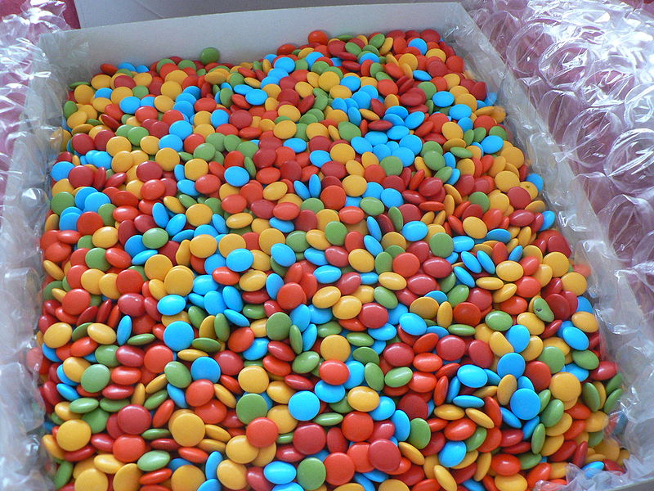
Homework pieces/ evidence should be handed into school on the first day back in the new term. Please make sure you have your name on them. Have fun! From the KS1 Team
How it Works
You simply need to pick your homework, aiming to spend at least 12p in total.
Year 2 Pick ‘n’ Mix October Break Homework

3p  With an adult, make your own meal and write the recipe.  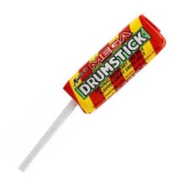 |   Practice your joined-up handwriting on LetterJoin at home daily!    5p | 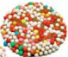  Practise your times tables x2, x5, x10. Get an adult to write questions down so you can answer them.  1p |   Practice all the spelling that you have learnt this term and put 5 of the words into sentences.  1p
Learn a playground song or clapping game to share with your friends next term.    2p | 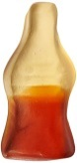  Boggle challenge: How many words can you make using these letters:  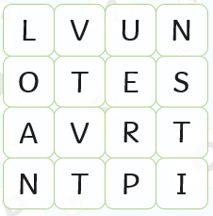  4p |   Go to the park and take part in energetic activities. Can you make up a new game to play?  2p |   3p  Write an acrostic poem about Neil Armstrong remember to use exciting words!
  5p  Reseach an activist like Malala Yousafzai. Can you write a report about their life? | 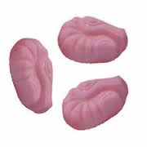  Write 3 facts about Rosa Parks.  1p |   How many books can you read over the October break. Write a book review for the one you enjoyed the most.  2p |   Spend some time doing brain breathing - perhaps do chair yoga or shut your eyes and listen to some quiet music.  2p

