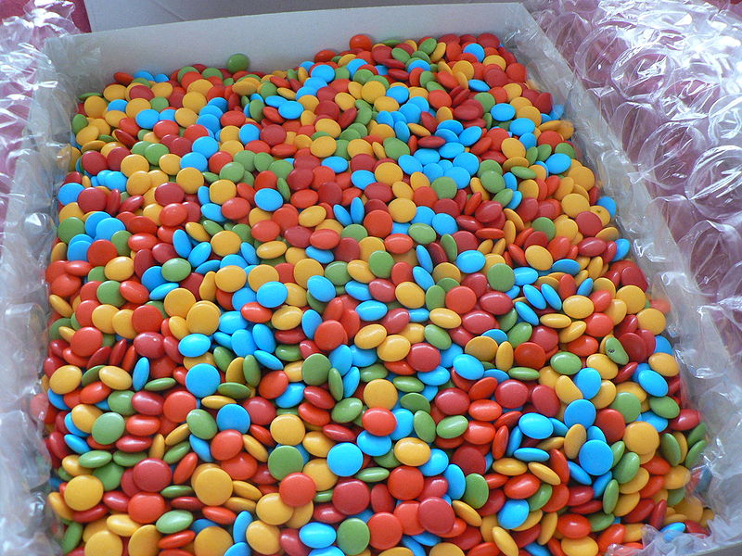
Homework pieces/ evidence should be handed into school on the first day back in the new term. Please make sure you have your name on them. Have fun! From the KS1 Team
How it Works
You simply need to pick your homework, aiming to spend at least 12p in total.
Year 1 Pick ‘n’ Mix October Break Homework

Speak to older members of your family to find out how their childhoods were similar to or different from yours, such as toys, food, home and school. Draw pictures or write some sentences to record what they say.  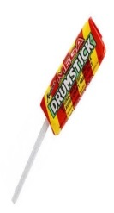  5p |   Practice your joined-up handwriting on LetterJoin at home daily!    5p | 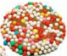  Practise counting forwards and backwards to 20. Can you write down your numbers?  1p |   Practice spelling numbers one to ten. (one, two, three, four, five, six, seven, eight, nine, ten)  1p
Learn a playground song or clapping game to share with your friends next term.    2p | 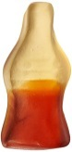  Boggle challenge: Make as many words as you can using these letters below. What is the longest word you can make?  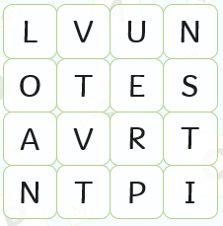  4p |   Use your garden or a park to take part in energetic activities. Can you make up a new game to play or learn a new skill?  2p |   Draw and label a map of your dream/themed playroom or children’s adventure park.  3p
  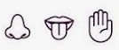  5p  Create a ‘guessing game’ for your family and friends using senses such as touch, taste or smell and record your findings! | 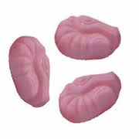  3p  Create some firework art using a range of materials.   |   How many books can you read over the October break? Draw a picture of the front cover of your favourite book.  2p |   Spend some time every day doing brain breathing - perhaps do chair exercises or shut your eyes and listen to some quiet relaxing music.  2p

