
You need to spend 7p to collect your stars when you hand it all in when you come back to school.
Tick each off as you go!

Homework should be by Friday 31st October.
Have a wonderful half term!
From Mrs Stanley and Mrs Magee.
Enjoy!
Year R Pick ‘n’ Mix Holiday Homework

How it Works
Each half term, you will be given a Pick ’n’ mix homework sheet. All you need to do is choose which pieces of homework you would like to do the most. The aim is to spend at least 7p in total this half term. Which pieces will you choose?

2p  Take turns with a friend or family member to play a game.  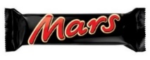 | 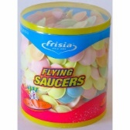  Can you write your numbers 1-10  1p |   2p  Can you build a house out of recycling items? | 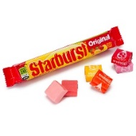  Can you go for a walk around your local park, and a draw a picture of something you see?  2p
Can you find the beat to your favourite song?    2p |   Can you practice writing your sounds?  What’s your favourite sound to draw?  2p | 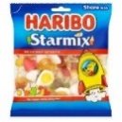  Read your favourite book with your grown up. Can you draw a picture of your favourite character?  1p | 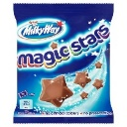  Can you draw a picture of a special event that your family celebrate?  2p


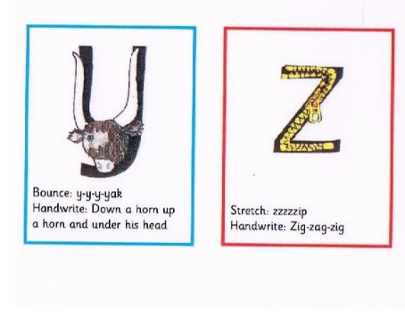
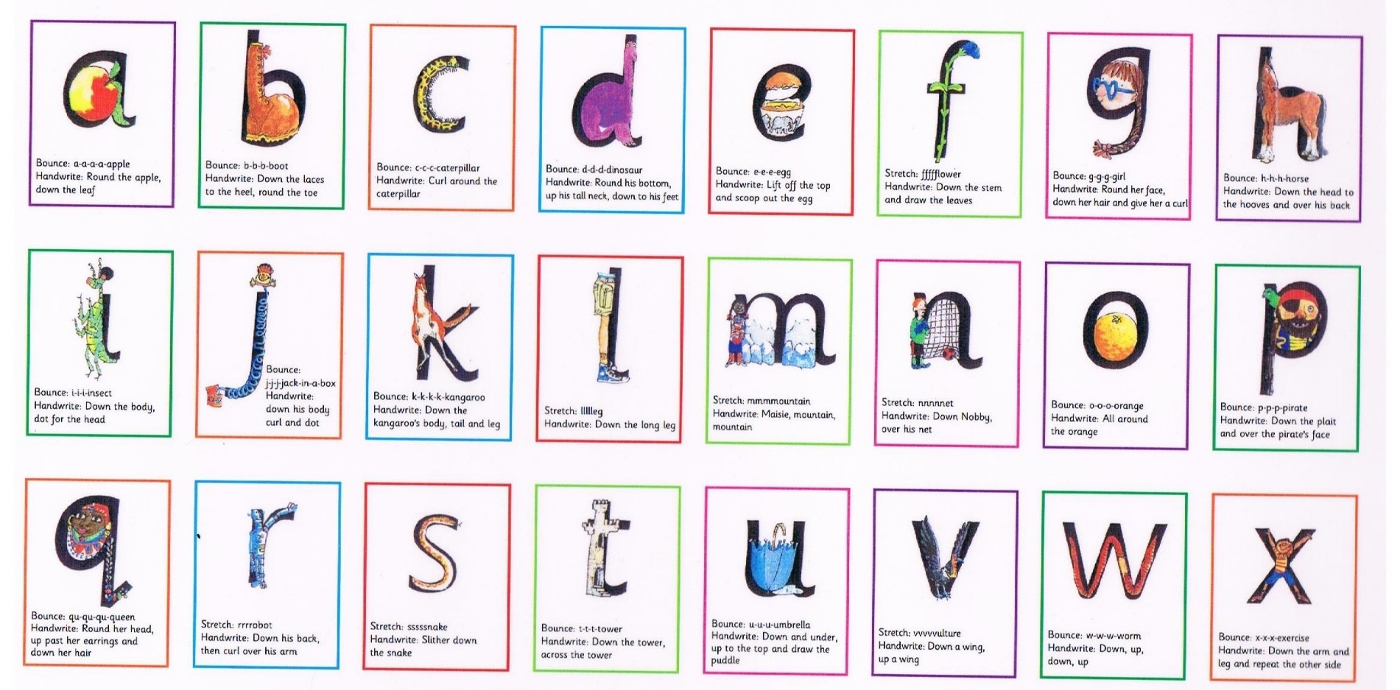
My name
____________________________

