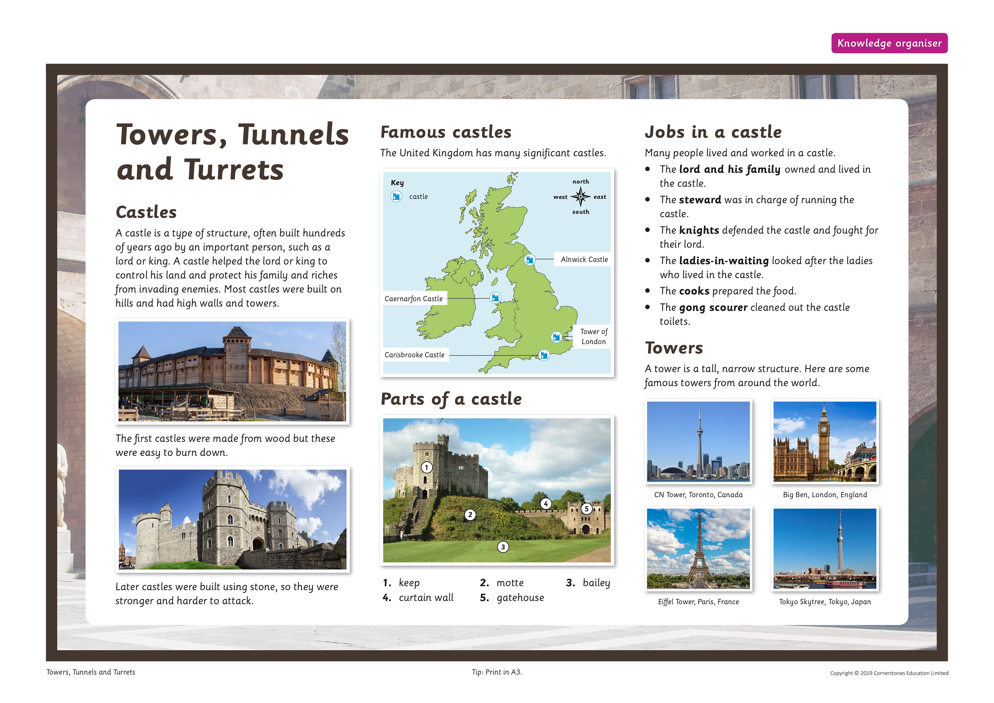

Key Questions

How have castles changed through the ages? Why is a designer or inventor important? Why are towers tall?

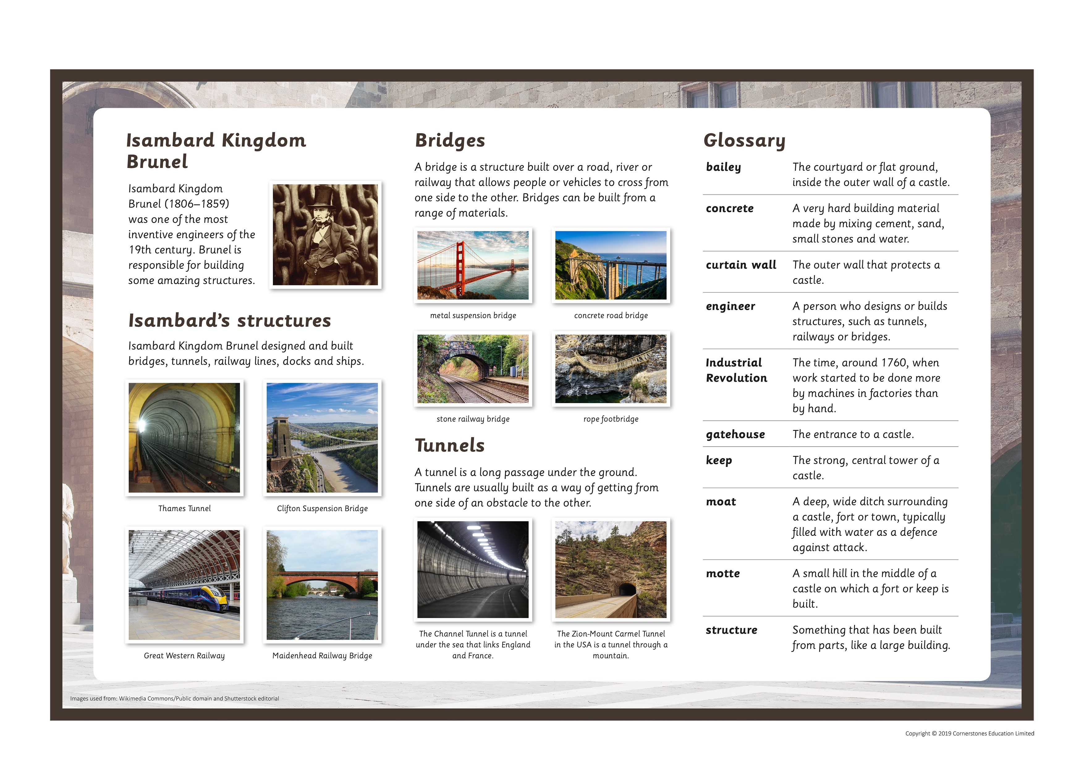
Book List
Rapunzel (Best loved classics) The Three Billy Goats Gruff (First loved stories) The Tunnel
Sarah Gibb Mara Alperin Anthony Brown

