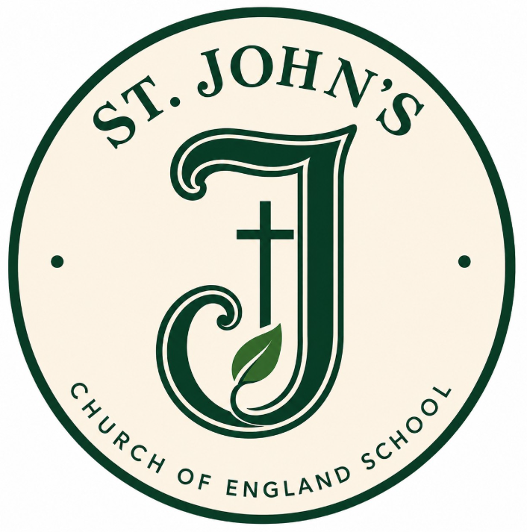

School Prospectus
September 2026 – July 2027

St John’s Church of England School
4 New Street Chatham Kent
ME4 5RH

Phone: 01634 844135

Visit our website at www.stjohns.medway.sch.uk


Welcome to St John’s Church of England School
I am extremely proud to be the Headteacher of our school family, supported by a highly skilled and dedicated team of staff and governors who are fully committed to improving life chances and building strong foundations for every child’s future.
At St John’s, we have high expectations for both our pupils and ourselves. We strive for all children to flourish, grow in confidence, and leave us as polite, independent learners with the skills, values and knowledge needed for the next stage of their education.
We aim to inspire a love of learning and encourage our pupils to face challenges with resilience, guided by our core values of faith and love, especially during more difficult times.
Our school is committed to providing the highest quality education within a stimulating, safe and nurturing Christian environment. We design a creative curriculum that engages and motivates children, offering opportunities for every child to succeed and enjoy achievement, regardless of their starting point or background.
We value strong partnerships with families and work closely with a range of external agencies to ensure that every child is supported to reach their full potential.
We are incredibly proud of our pupils and all that they achieve during their time at St John’s.
We hope this information pack, alongside our website, provides everything you need as your child begins their journey with us. However, you are always very welcome to arrange a visit and experience first-hand what makes St John’s such a special place for children and families.
We look forward to working in partnership with you.
Mrs Edwards
Headteacher

Our School Vision

The school Christian vision that underpins all of our decisions and actions is:

It has it's Biblical origins in the parable of a mustard seed; Matthew 13;31, when Jesus told the people who were suffering from darkness and sin in the world that if they had even just a little bit of faith in God (just the size of a mustard seed) their lives would get better, God would nourish them like a plant and watch them grow into a big and mighty tree where the birds of Heaven sought shelter and comfort in their branches.
The visual representation of the vision that the children collectively devised is below. If you look carefully at the heart of the tree just above the nurturing hands you will see the 2 'seeds ' or values of faith and love that underpin all decision making, actions and policy formulation within our school.

School Admission Arrangements

Children are admitted to St John’s School at the beginning of the Autumn term in September.

All families are offered a home visit by a member of the Reception team. These have been found to be invaluable especially when the families have had no previous links with the school.

A visit for a ‘Play and stay’ is arranged prior to entry as well as a transition meeting with the Reception team and Headteacher.


School Arrival Times and Procedures

The school gates are opened to children from 8.40am and they make their way straight into the school building to their classrooms. The register is taken at 8.45am for all children and any child not in class at these times up until 9.30am will be marked late. The gate is closed at 8:55am and any child arriving after this time must go through the school office into school.

Accidents and Illnesses that occur during school time

In the event of any accident or illness, parents are notified as soon as possible. Minor accidents will be attended to during the school day by trained first aiders. When it is inappropriate for the pupil to remain in school, parents may be requested to collect their child. When parents cannot be consulted immediately, action in respect of first aid, medical assistance or hospital treatment is taken as deemed appropriate. It is essential that the school has an up-to-date emergency contact telephone number for every pupil and that parents notify the school at once if this number changes.


School Attendance

Attendance is a key priority at our school, and we are committed to maintaining high levels of attendance for all pupils, aiming for at least 97%. We ask that parents contact the school by telephone or email on the first day of any absence as soon as possible, providing a reason. Repeated or unexplained absences will be followed up, including support from the council’s Attendance Advisory Practitioner where needed. Punctuality is also very important, and each child’s attendance is reported in their end-of-term report.
If you need to request an absence in advance (for reasons other than illness), please write to the school outlining the exceptional circumstances. In line with guidance, the school is unable to authorise such absences; however, if we are informed in advance, staff can prepare work to help your child keep up with their learning.
To encourage strong attendance, children who attend every day in a week receive a raffle ticket, which is entered into a termly prize draw. The more tickets they collect, the greater their chance of winning one of the exciting rewards.

Snack Time
The ‘Cool Milk for Schools’ initiative operates at this school on a daily basis for Foundation Stage children and they get free milk up to the age of 5yrs.
Children in Foundation Stage and Key Stage 1 are provided with a piece of fruit or vegetable for free as a snack at morning break time.

Charging Parents for Activities
The school follows the policies laid down by Medway Education Authority regarding charging parents for school activities.

Charges and voluntary contributions are sought from parents to facilitate the participation of pupils in ‘special’ activities that take place during school hours and for extra curricula activities/school trips.

Communication between Home and School

We encourage electronic communication where possible. All information is sent home via ARBOR or email, important messages and alerts may also be sent to parents via text. Paper copies of letters emailed to parents are still available upon request – just ask at the school office if you would prefer this.

We are also use a communication platform called Dojo. You will be invited to join your child’s class Dojo when your child starts our school. ClassDojo is a communication platform we use to strengthen the partnership between school and home. It allows teachers to share updates, celebrate children’s achievements, and communicate quickly and securely with parents. Through ClassDojo, families can see photos of learning, receive important notices, and stay informed about what is happening in school. It also helps to promote positive behaviour by rewarding children for their efforts and encouraging a consistent approach between school and home. This app is free to use and please do not pay for the upgrade when you sign up as it is not necessary.

Community Links


St John’s School makes a positive contribution to community life, supporting many organisations in Chatham and the local area. The school is aware of its valued place within the community and enjoys a very close relationship with St John’s Church. We are also increasing our links with local retirement homes, and our children will be invited to read with residents weekly.

As a school, the staff raise pupil awareness of the needs of others and participate in a range of fundraising events to assist those less fortunate than ourselves.

Our School Curriculum
Our curriculum is designed to inspire a love of learning and help every child enjoy a rich and engaging school experience. We aim to support each child to reach their full potential, both academically and personally, and we value the important role parents play in their child’s learning.
We provide a broad, balanced and creative curriculum with exciting topics that make learning fun, meaningful and memorable. Through hands-on experiences, discussion and problem-solving, children develop a deeper understanding across all subjects.
Teaching is carefully adapted to meet the needs of every child. Staff use a range of approaches, including whole-class teaching, group work and individual support, to ensure all pupils are challenged and supported to make strong progress.
We also use the strengths of our staff team to provide high-quality teaching and enriching learning experiences.
Above all, we aim to develop confident, curious and independent learners who are well prepared for the next stage of their education.

The Early Years Foundation Stage Curriculum

In our Early Years Foundation Stage (EYFS), children experience a rich and varied curriculum based on seven key areas of learning, including communication, physical development, literacy, maths and creativity.
Our EYFS setting is carefully planned to provide a safe, nurturing and stimulating environment where children can learn through play, exploration and hands-on experiences. We offer a wide range of indoor and outdoor activities that encourage curiosity, independence and confidence.
Children take part in daily phonics sessions in small groups to support early reading and writing. These skills are developed further through a mix of adult-led activities and child-initiated play.
We place a strong focus on developing communication skills and supporting children’s personal, social and emotional development, helping them to build relationships and grow in confidence.
Our approach ensures every child is supported and challenged, giving them a happy, secure and inspiring start to their school journey.



Positive Behaviour Policy
Behaviour at our school is underpinned by the belief that every child has the right to feel safe and to learn without disruption. We promote a positive, respectful and well-ordered environment where all children are valued as individuals and where effort, kindness and success are recognised and celebrated.
When behaviour falls below expectations, we use a clear and consistent approach to support pupils in making better choices. A structured system of strategies and consequences is in place across the school, ensuring fairness and consistency for all. Parents and carers are kept fully informed and involved, so that we can work together to support each child’s behavioural needs effectively.
While there are clear consequences for persistent poor behaviour, including the possible temporary withdrawal of privileges or, in more serious cases, suspension or exclusion, our primary focus is always on prevention and support. We place strong emphasis on positive behaviour strategies, including the use of ClassDojo to recognise and reward positive choices, and we work closely with families to build strong, consistent relationships between home and school.

School Policies

School guidelines and policies are regularly revised and updated. Copies of these are available on request from the school office and some are also posted onto the school website.

Homework

Research shows that homework plays an important role in supporting pupils’ progress, as it reinforces and builds on learning from the classroom.

Children are set weekly homework appropriate to their age and needs, which may include reading, English, maths, spellings, research tasks, challenge activities, or completing unfinished class work. We ask for parental support in ensuring homework is completed to a good standard and returned to school on time.

We also encourage children to practise reading, spellings and times tables for around five minutes each evening to help develop key skills. Further information about homework expectations will be shared at the beginning of the year during our ‘Meet the Teacher’ sessions.


Medicines
Prescribed medication can be administered in school by a first aid trained member of staff if it has been prescribed by a doctor to be taken four times per day.
Parents are required to complete and sign a school medical record form, which is available from the school office.
Please ensure that all medicines sent to school are clearly labelled with your child’s name and required dosage.
Medication linked to long term medical needs such as asthma inhalers and EpiPens may be sent into school and should be handed directly to the class teacher. These must be clearly marked with the child’s name too. A medical plan will also need to be completed if your child needs to have these in school.

Medical Appointments

Pupils leaving school mid-session for a hospital or other medical requirement will need to be signed out from the school office by their collecting adult. Please provide proof of appointment so the absence can be authorised.

Pastoral Care

As a school, we place high priority on the individual needs of each child. If there is anything important that has affected the family at home and you think the school should know, please inform the Class Teacher either via email or contact the school office directly.

Progress Reports and Parent – Teacher Consultations
At the beginning of each school year there is a ‘meet the teacher’ meeting where all parents are invited to a presentation so that adults can find out the expectations of their child as they move on to the next year group in their schooling career. This takes place in September and you will be invited to this via the class teacher on Dojo.
Pupil progress is shared with parents regularly and written reports are sent home to parents twice across the school year.

Parent-teacher consultations take place twice a year and Book Looks take place regularly so that parents can come into school to view their child’s work and to chat with their teacher about progress.

Class teachers inform parents of curriculum content at the start of each term via Knowledge Organisers and school encourage parents to read through these at least weekly with their child so that the children can commit the facts contained on it to memory. A weekly newsletter is also sent out to all parents via Dojo informing parents of any important information or news that may have happened that week.

Pupils who have English as an Additional Language

Children whose first language is not English will be given extra language support where needed to develop their skills, concepts and knowledge. Support is given to enable bi-lingual pupils to participate in, and have equal access to, all areas of the curriculum. It also ensures that pupils relate their cultural experiences to the curriculum to increase their motivation, encourage a positive self-image and to achieve well.



Pupils who are eligible for Pupil Premium Funding

Pupil Premium Funding is additional money for publicly funded schools in England. It is provided in order to for schools to help raise the attainment of economically disadvantaged pupils and to close the educational gap that exists between them and their more affluent peers.

Your child could be eligible for PPF if:

- They have qualified for free school meals at any point in the past six years.
- They have been looked after under local authority care for more than one day.
- They have a parent in the military forces.

If you think that your child may be eligible please speak to the school office and complete a short form to find out.



Pupils who have Special Educational Needs

We aim to provide equality of access to a broad and balanced curriculum for all pupils including those with special educational needs. All pupils are assessed regularly within school. If the results of any assessment indicate that SEN intervention is required, pupils are supported with specific programmes of learning in order to meet individual needs as laid out in the SEND Code of Practice.
In all cases where SEN intervention is required, parents are kept fully informed about the progress of their child. Our SENCo is Mrs Campbell.

Times of the School Day

Gates open: 8:40am
Registration: 8:45am
Morning break: 10:45-11:00am
Lunch time: 12:00-1:00pm
School finishes: 3:15pm
Wraparound after school care: 3:15pm-6pm

School Dinners

All pupils have the option of a school meal or a packed lunch from home.
The children in the Early Years Foundation Stage and Key Stage 1 are offered a free school meal but they can bring in packed lunch if they like. These need to be booked directly with ‘School Food United’ and more information regarding this will be sent out separately.

Packed lunches should be brought into school in a lunch box. Please do not send fizzy drinks or anything in a can or glass bottle. Sweets, chocolate and crisps should also not be included in lunch boxes. We are a “Healthy School” and encourage our pupils to adopt a healthy attitude towards food and exercise.
We are also a ‘NUT FREE SCHOOL’ as we have children and staff that have life-threatening allergies. Please ensure your child’s lunch does not contain any products that have nuts in them, such as Nutella.

Children are supervised at all times during their school lunch break by a group of trained Midday Meal Supervisors.

School Uniform

A school uniform greatly contributes to a child’s sense of belonging and pride. Our school uniform colour is green. It does not have to have the school logo on it, however, if you wish to: St Johns School sweatshirts, cardigans, coloured and book bags all bearing the school logo can all be bought online – see the school website. From September 2026, our colour is changing from red to green. This is a gradual approach as Year 1 and Year 2 will still be in red.
All Reception children will have two green jumpers donated to each child at the start of their Reception year from the school. These will be sourced from Uniform base and will include the new school logo on there.

For PE all children need to have plimsolls/ trainers, a white t-shirt and navy blue or black shorts. These need to be kept in school in their cloakroom inside a PE bag. Plain navy or black leggings/tracksuit bottoms are additional, recommended for outside PE in the winter months.

Please ensure all items of your child’s clothing are named to help avoid loss.

Children are not allowed to wear jewellery to school except small stud earrings / religious bangles. If watches are worn to school, they are the responsibility of the individual child.

School Trips


Many educational visits are arranged for the children throughout their schooling career, and we feel that these are an integral part of pupil learning. Parents will be notified of trips in advance and information will be provided to parents about them. If insufficient funding is received from parents in time, trips may have to be cancelled with short notice.

When children join the school, parents complete a blanket consent form stating that they give the school permission to take their child off the school site to places in the local area. Some information packs about trips will not include a parental permission form. If parents do not wish their child to attend an activity off school site they will need to withdraw their child by writing a letter and explaining their reasons for not wishing their child to go.

Special Medical Care
Parents of pupils who require a special routine of medical care, eg sufferers from epilepsy, diabetes or asthma, should notify the class teacher / office staff of the situation and any special precautions that need to be taken with their child.

Complaints
Although we receive them very rarely, we regard any complaint concerning the school very seriously, and will listen to your views and take appropriate action as necessary.

In the event of a parent wishing to make a complaint, an appointment should be made to discuss the problem firstly with the class teacher, secondly with the appropriate senior leader and then thirdly, if necessary, with the school Headteacher if the first two meetings do not successfully improve the matter in question.

If, going through this three tiered process does not resolve the matter, the parent should read the school’s/ MAST trust complaints policy available on the school’s website and act in accordance with the process outlined within it- filling in the complaints form contained within it and sending it into the school office.
Luckily most matters can be resolved by coming in for a chat and talking through issues together- always with the interests of the child at heart.

We welcome both you and your child to the St John’s family and look forward to celebrating your successes as we all flourish and grow together.

